**Math 120**

**Test 3B**

**Student Name: _______________________________________ Student Number: ______________________**

**Directions:**

* SHOW ALL YOUR WORK OR JUSTIFICATION FOR ANSWERS *ON THE TEST*. Scrap paper is sometimes hard to read and I want to give you partial credit!
* Simplify all answers.
* Round answers as indicated.
* Include units with final answers.

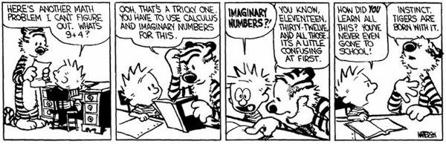

* 1. Use the following two points to answer the questions below: (-2,3) and (1,-1)

1. Find the distance between the pair of points.

a.______________________

1. Find the midpoint between the two given points.

b.______________________

* 1. The graph of the circle follows

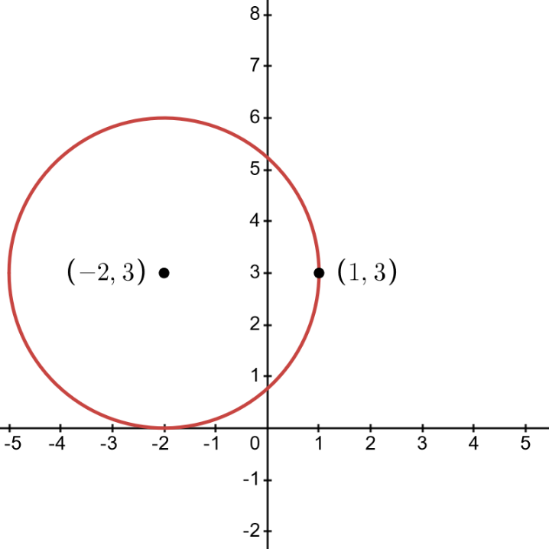

1. Find the radius of the circle. Show your work for full credit.

a.______________________

1. Use the graph and part a to write the equation of the circle in standard form.

b.__________________________________

* 1. The graph of the circle follows

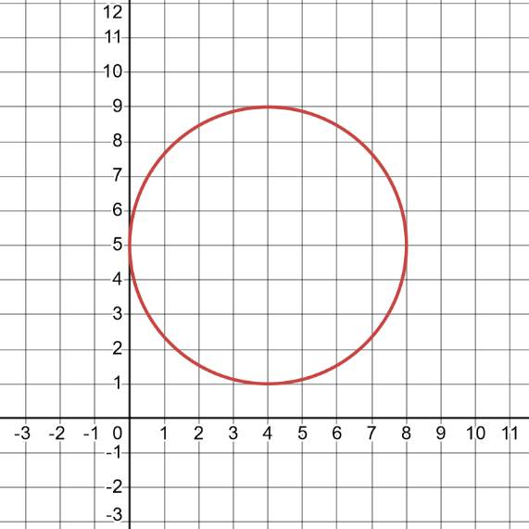

1. Find the domain. Answer in interval notation.

a.______________________

1. Find the range. Answer in interval notation.

b.______________________

* 1. The graph of the circle follows

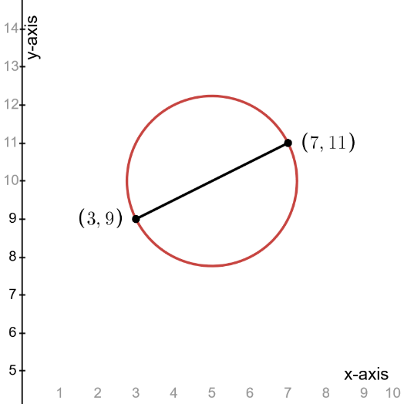

1. Find the coordinates of the circle’s center. Show your work for full credit.

a.______________________

1. Find the radius of the circle. Give the exact answer.

b.______________________

1. Use your answers from parts *a* and *b* to write the standard form of the circle’s equation.

c._________________________________

5. Write the following equation in standard form. Then give the center and radius of the circle.



Standard Form ____________________________________

Center _______________________

Radius _______________________

6. Use the following graph.

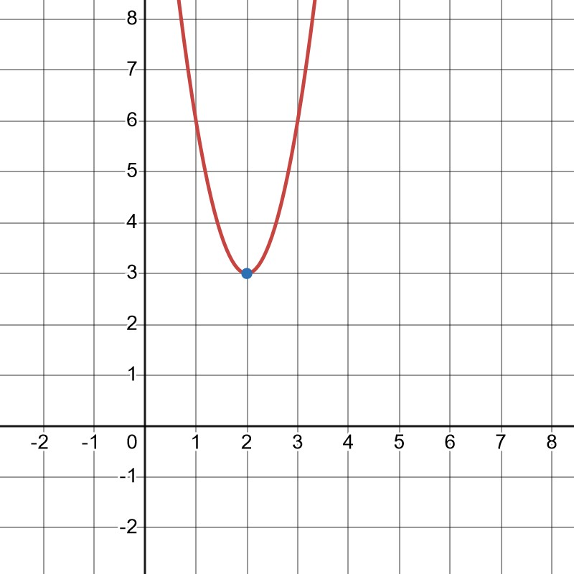a. Identify the vertex. _____________________________

b. Using your answer from part a, write an equation in *standard form* of the parabola that has the same shape as the graph of  and has the given vertex above.

______________________________

7. The Detroit Tigers Major League Baseball team’s season is done but we can’t stop thinking about their great run in the playoffs! Center fielder Riley Greene hits a baseball. The ball’s height in feet, *h(t),* after *t* seconds is given by . Include units in all your answers. Round all answers to the nearest tenth.

1. What is the ball’s height when the batter makes contact with it? HINT: Think about what your *t* value is at this moment.

________________________

1. What is the *maximum* height of the ball? ________________________
2. When does the ball reach that height? ________________________

8. It’s Christmas time and Eliza has to keep her tree away from her twin toddlers! Below is an overhead picture of her tree pushed up against the wall and the rectangular 3 sides of fencing she is going to use to keep them out! All sides are measured in feet.

wall

x

x

20 - 2x

1. Find a function *A(x)* to express the area of the rectangle as a function of *x* the width.

________________________

1. Find the width that will maximize the area. Include units. ________________________
2. Find the length that will maximize the area. Include units. ________________________
3. What is the largest area that can be enclosed? Include units. ________________________

9. A quadratic function is given.



1. Find the vertex without graphing. Show your work for full credit.

a.______________________

1. Determine whether the vertex is a maximum or minimum. Circle one. MINIMUM OR MAXIMUM
2. Explain in a sentence how you know the answer to part b given only the equation and not looking at the graph.

__________________________________________________________________________________________

__________________________________________________________________________________________

__________________________________________________________________________________________

10. For the following function, find the zeros and give the multiplicity of each. CIRCLE whether the graph will cross at the x-axis OR turn and hit.



Zero ______________________ multiplicity___________________ CROSS OR TURN

Zero ______________________ multiplicity___________________ CROSS OR TURN

11. Use the quadratic function to answer the following questions.



1. Use the Leading Coefficient Test to determine the graph’s end behaviors. Circle one for each end.

LEFT: FALL or RISE

RIGHT: FALL or RISE

1. Find the zeros. Use exact values and simplify.

________________________

1. Find the y-intercept.

________________________

12. A graph of a polynomial function whose zeros are integers is shown.

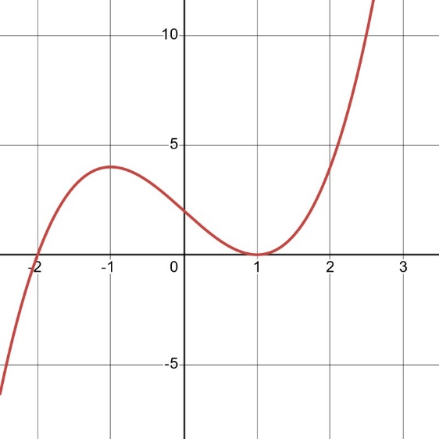

a. Find the zeros and state whether the multiplicity is even or odd.

Zero _____________ multiplicity____________

Zero _____________ multiplicity____________

b. Write an *equation*, expressed as the product of factors, of a polynomial function that might have this graph. Use a leading coefficient of 1 or -1, and make the degree of *f* as small as possible.

___________________________________

13. Match the information to the graph. Write in A, B, C, or D in the blanks. REMINDER: *N* is the degree of the function and *a* is coefficient of the dominant term.

A B C D

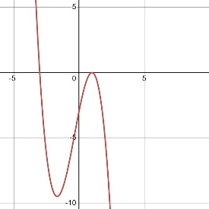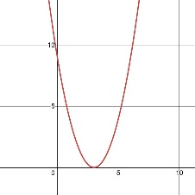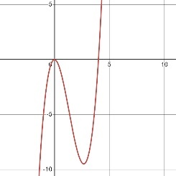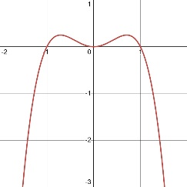

*N* is odd, a < 0 _____________________

*N* is odd, a > 0 _____________________

*N* is even, a < 0 _____________________

*N* is even, a > 0 _____________________

14. Write the equation of a polynomial function f with the given characteristics. Use a leading coefficient of either 1 or -1 and make the degree as small as possible.

zero at $x=-5$ with multiplicity 1, zero at $x=-2$ with multiplicity 3. End-behavior Rise Left, Falls Right

_____________________________

15. Given the graph below, identify and list any asymptotes.

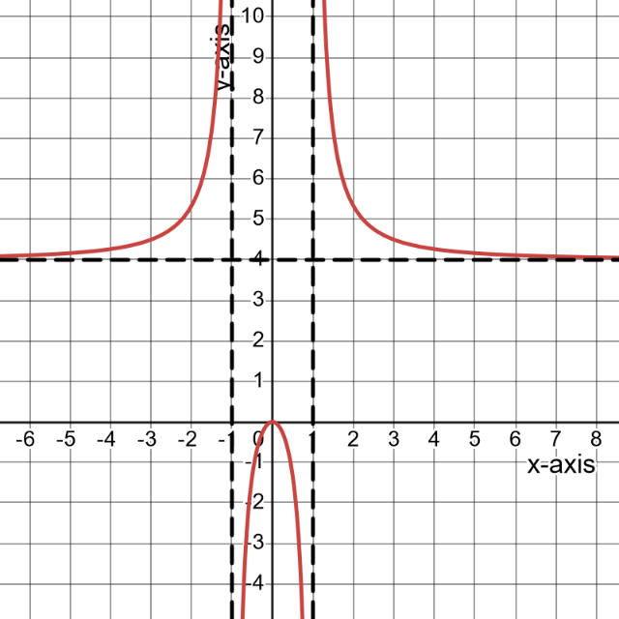

_____________________________________________________

16. Find the domain of the rational function. Answer in interval notation.



________________________________________

17. A college student is tracking their progress in building muscle mass. The amount of muscle mass *M(t)*, in kilograms, earned each month *t* of regular strength training, can be modeled by  t ≥ 0. This model assumes that the rate of muscle gain per month is proportional to the intensity and consistency of the strength training regimen, represented by the numerator 4t. The denominator represents potential factors such as genetic limitations, plateaus, or diminishing returns over time as the body adapts to the training stimulus.

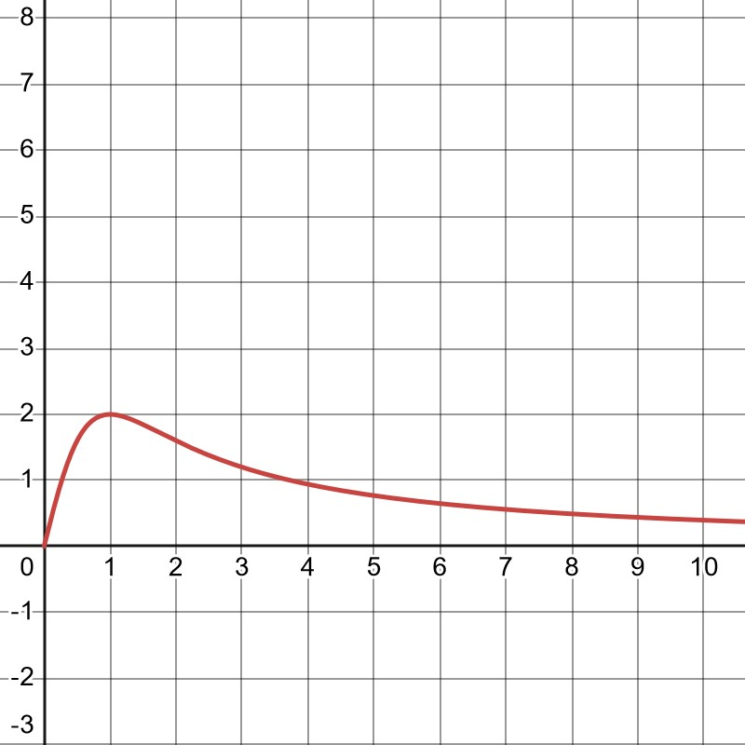

a. Explain why t ≥ 0 in both the equation and the graph in the context of the problem.

__________________________________________________________________________________________

__________________________________________________________________________________________

__________________________________________________________________________________________

b. What is the muscle mass of the student earned at 3 months? Round to the nearest tenth and include units.

_____________________________

c. Find the equation of the horizontal asymptote. In complete sentences, explain its meaning in the context of the problem.

__________________________________________________________________________________________

__________________________________________________________________________________________

__________________________________________________________________________________________

__________________________________________________________________________________________

18. The equation of a rational function is given.



1. Find the equation of all vertical asymptote(s), if any. ________________________
2. Find the equation of the horizontal asymptote, if any. ________________________

19. C varies jointly as A and T. C = 175 when A =2100 and T =4.

1. Write a general equation showing the relationship between C, A, and T. __________________
2. Find C when A=2400 and T=6. __________________

20. When a stone is tied to a string, and whirled in a circle at constant speed, the tension T in the string varies inversely as the radius R of the circle. If the radius is 55 centimeters, the tension is 80 newtons. Find the tension when the radius is 100 centimeters.

______________________

**Formula Sheet: Math 120**

**Straight Line**

Slope Intercept form Point-slope form Slope

  

**Difference Quotient Quadratic Formula**

 

**Logarithms**

  

**Distance**:  **Midpoint**: 

**Circle**: 

**Quadratic Function**

, Vertex =  , Vertex = 

**Compound Interest**:  **Continuous Compound Interest:** 

**Arithmetic Sequence Geometric Sequence**

 Finite:  

 Infinite: , 

**Even function Odd function**

 